**Data Types**

**To let out system understand which type of data we are giving**

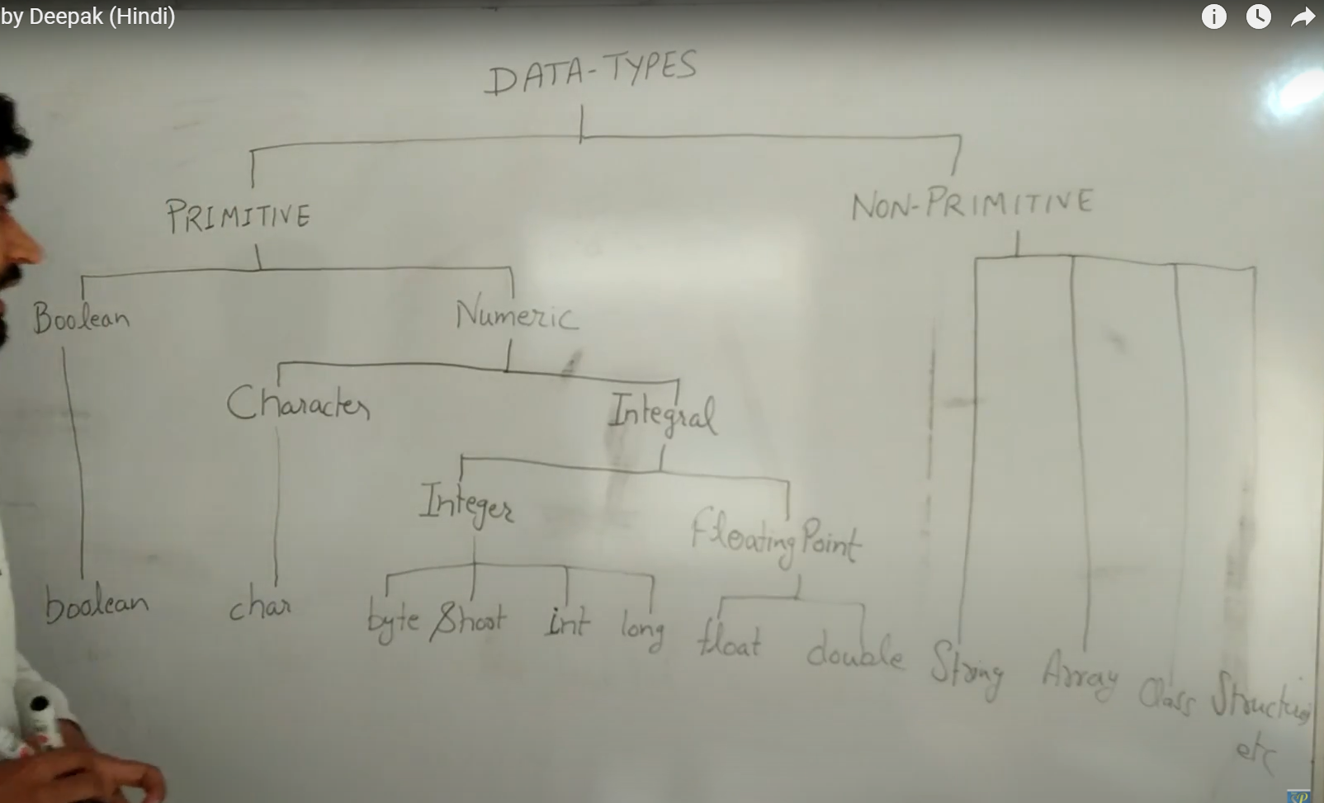

**Primitive types….we have fixed sizes**

**Boolean—jvm will decide**

**To control primitive data types we have corresponsing wrapper classes.starts with caps**

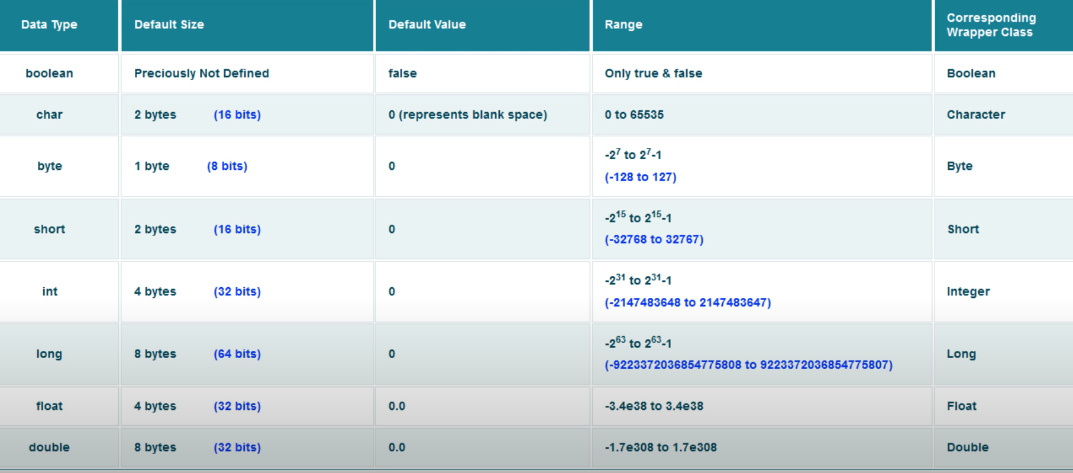

**Non primitive ---size is not fixed…at run time jvm wil allocate the size**

**Eg:**

**Char c=’a’**

**String=collection of charactors**

